Overview - Large Language Models and Prompt Engineering

[Previous](https://olympus.mygreatlearning.com/courses/111352/modules/items/5520745?pb_id=17388)

[Next](https://olympus.mygreatlearning.com/courses/111352/modules/items/5520701?pb_id=17388)

#### [NLP_Upt-Week-4-Journey-Map-1.png](https://olympus.mygreatlearning.com/courses/111352/modules/items/5520701?pb_id=17388)

#### **QUICK RECAP**

In the previous week, we learned about transformers, how they utilize the concept of self-attention, and different transformer architectures. Let us quickly recap what we have covered so far.

* Introduction to Transformers
* Introduction to Attention Mechanism
* Components of a Transformer
* Types of Transformer Architectures
* Training and Fine-tuning Transformers
* Applications of Transformers

#### **COURSE OVERVIEW**

**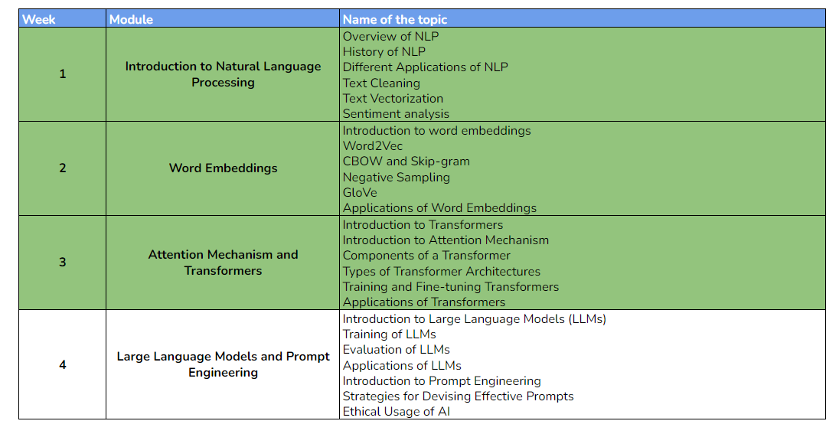**

#### **WEEK 4 OVERVIEW**

This week, we will be learning about large language models, how they work, their applications, and the importance of prompt engineering. The following topics will be covered in this module:

* Introduction to Large Language Models (LLMs)
* Training of LLMs
* Evaluation of LLMs
* Applications of LLMs
* Introduction to Prompt Engineering
* Strategies for Devising Effective Prompts
* Ethical Usage of AI

#### **LEARNING INSTRUMENTS**

| **Week** | **Module** | **No. of Videos** | **Total Duration** | **No. of Test Your Understanding Quizzes** | **No. of Graded Quizzes** | **No. of Practice Assignments** |
| --- | --- | --- | --- | --- | --- | --- |
| 1 | Large Language Models and Prompt Engineering | 11 | ~2 hours | 11 | 1 | 1 |

#### **Note:** It is recommended to spend at least 1 hour/day along with practicing datasets and quizzes.

**Power Ahead!**